Year 10 |  | Simultaneous Equations | Non Calculator
Skills and Knowledge Assessed:  - Solve linear simultaneous equations, using algebraic and graphical techniques including using digital technology (ACMNA237) |  |  | Name_________________
Section 1 Short Answer Section
Write all working and answers in the spaces provided on this test paper.

Find the point of intersection of the lines without drawing a graph.

……………………………………………………………………………………………....

……………………………………………………………………………………………….
Solve simultaneously :

……………………………………………………………………………………………....

……………………………………………………………………………………………....

……………………………………………………………………………………………….
What is the x value of the point of intersection of

..........................................................................................................................................................

..........................................................................................................................................................

..........................................................................................................................................................
Solve the simultaneous equations:

..........................................................................................................................................................

..........................................................................................................................................................
..........................................................................................................................................................
Find the values of s and t for which

..........................................................................................................................................................

..........................................................................................................................................................

..........................................................................................................................................................
Find the point of intersection of

..........................................................................................................................................................

..........................................................................................................................................................

..........................................................................................................................................................
 | 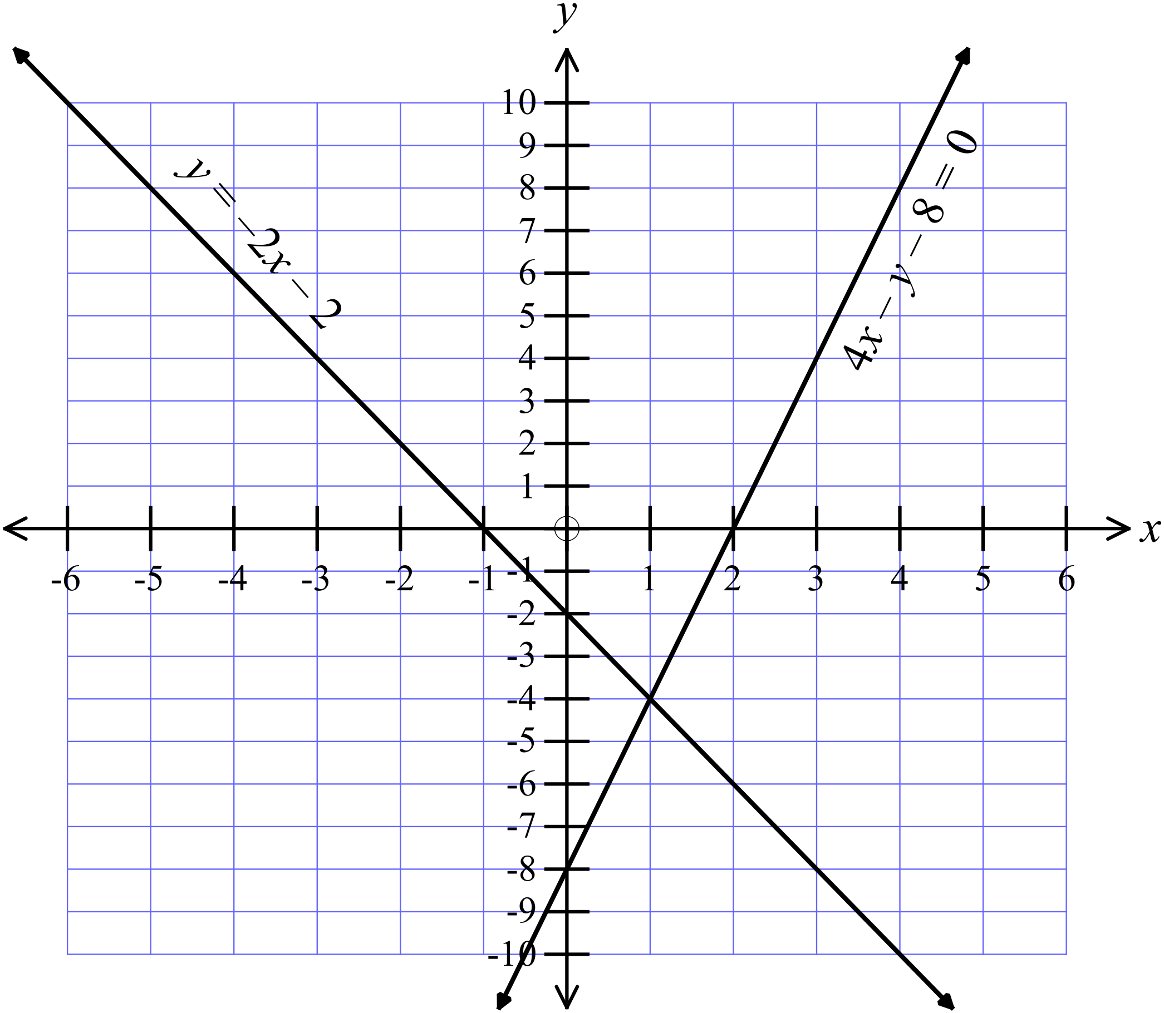Questions 7 – 11 refer to the graph below.
 | Sketch 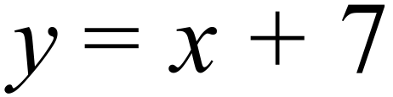 on the graph above
 | Sketch 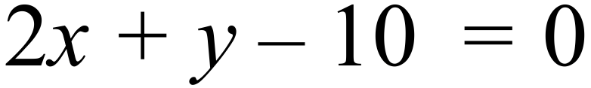 on the graph above.
Solve simultaneously: 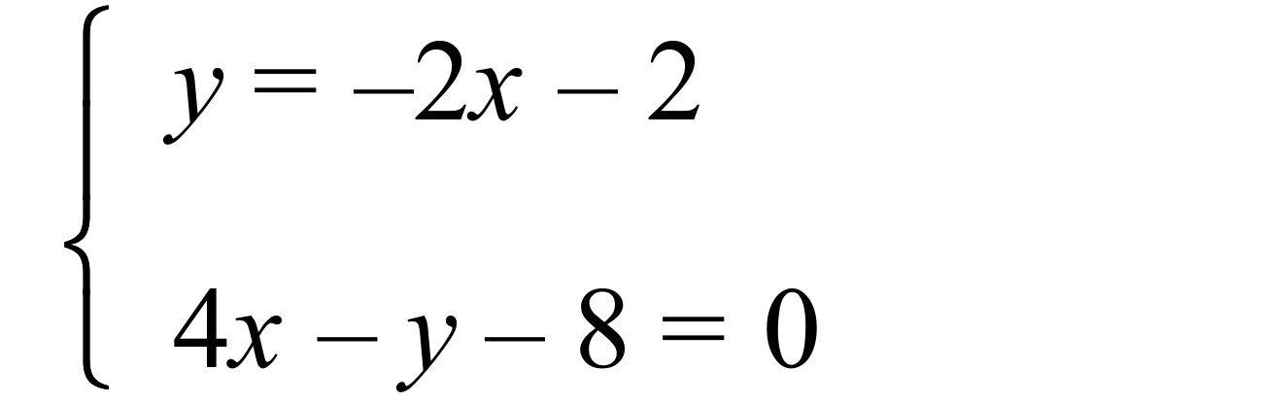
..........................................................................................................................................................
Solve simultaneously: 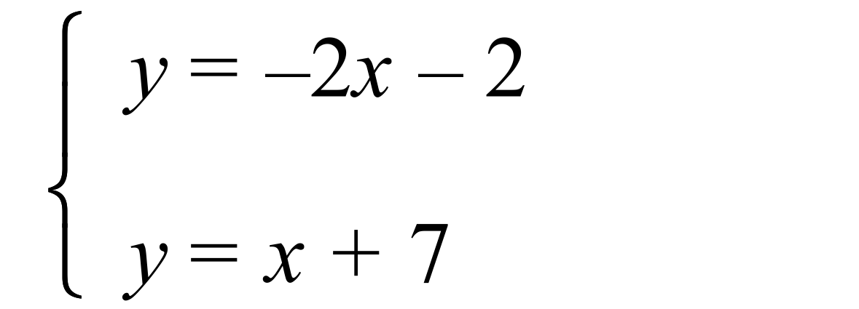
..........................................................................................................................................................
Solve simultaneously: 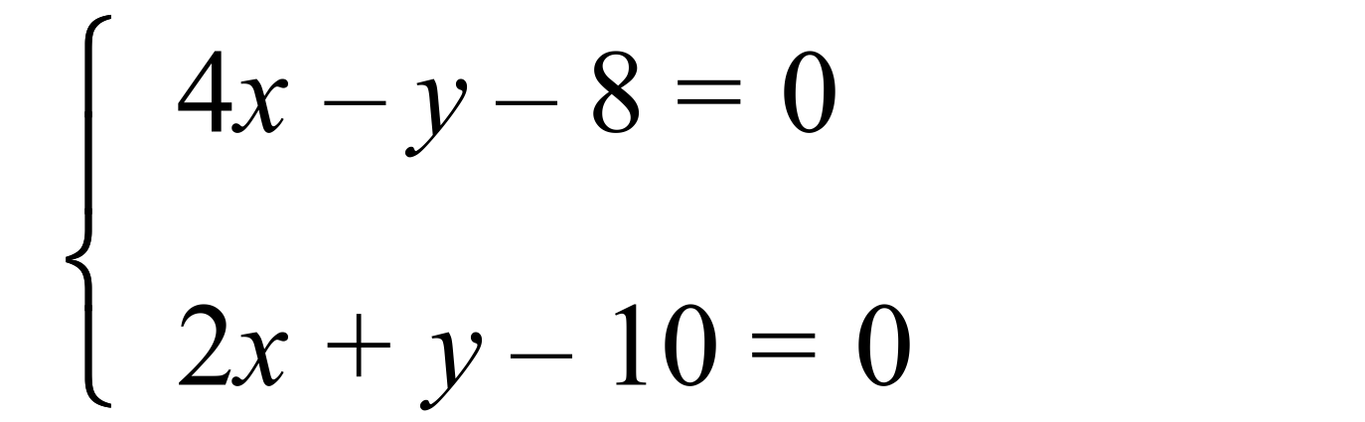
..........................................................................................................................................................
Solve simultaneously: 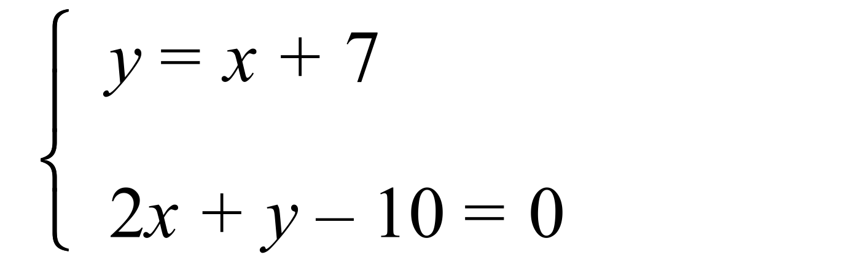 s
..........................................................................................................................................................

Year 10 |  | Simultaneous Equations | Calculator Allowed
 |  | Simultaneous Equations | Name_________________
Section 2 Multiple Choice Section
Mark all your answers on the accompanying multiple choice answer sheet, not on this test paper. You may do any working out on this test paper. Calculators are allowed for this section.

Solve simultaneously 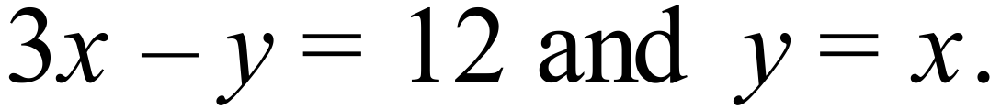

A. 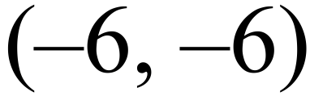 B. 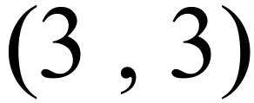 C. 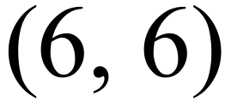 D. 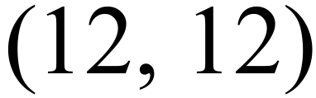
Solve simultaneously

A. 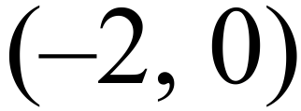 B. 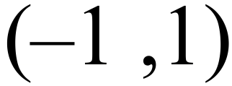 C. 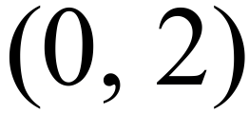 D. 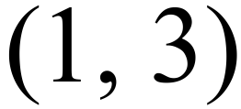
Questions 3 and 4 refer to the following:
A partially completed solution to a pair of simultaneous equations is shown:
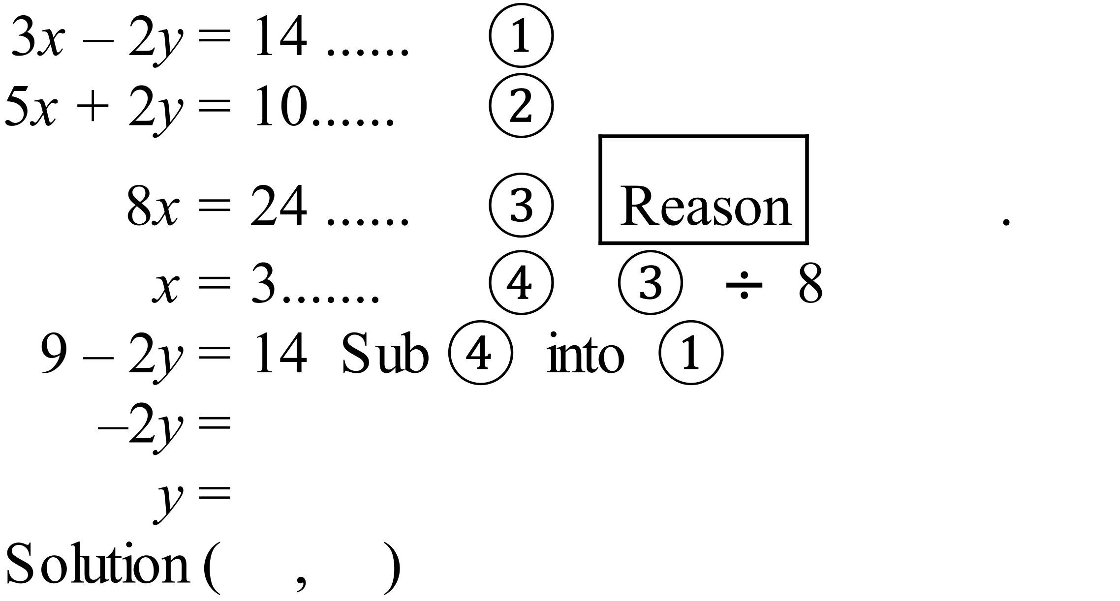
What reason should be given for equation 

A. 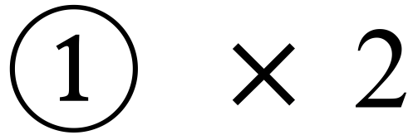 B.  C.  D. 
What is the final solution to the simultaneous equations?

A. 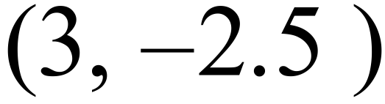 B. 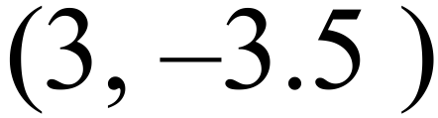 C. 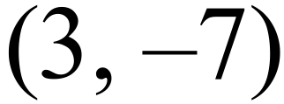 D. 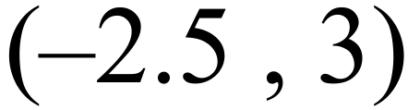
What ordered pair is a solution to the simultaneous equations below?
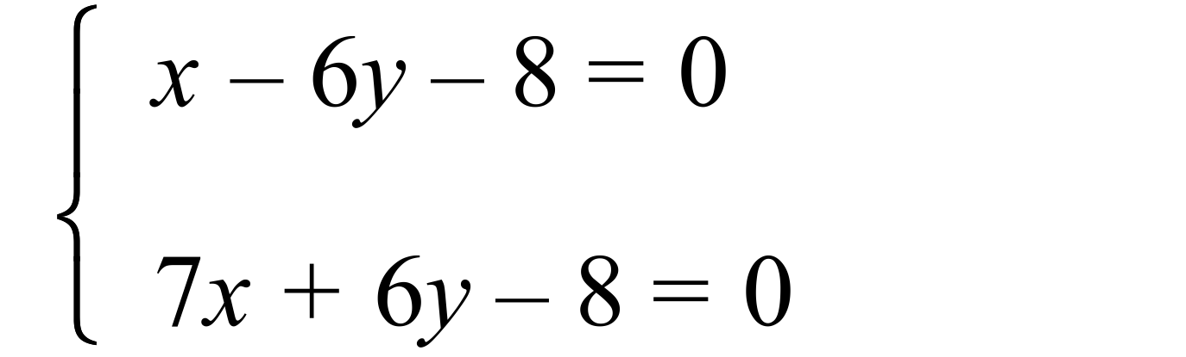

A. 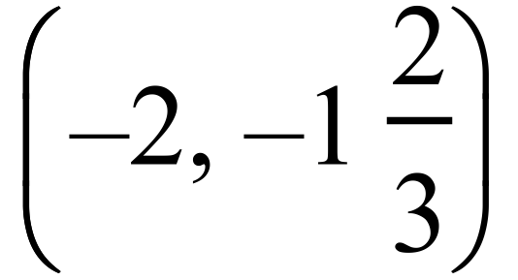 B. 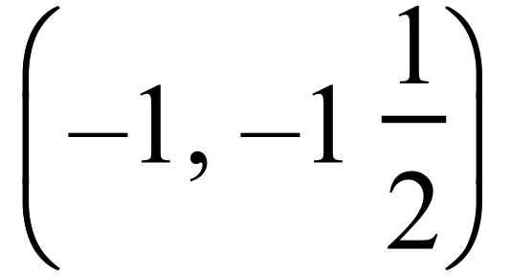 C. 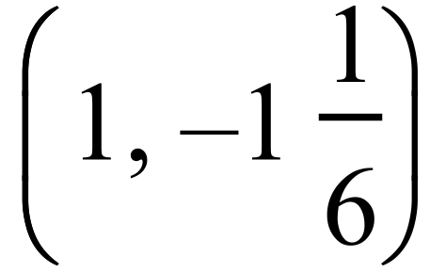 D. 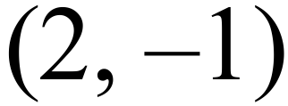
Solve simultaneously

A. 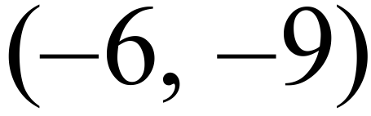 B. 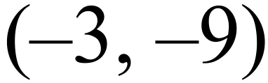 C. 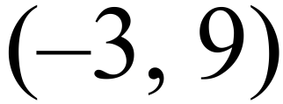 D. 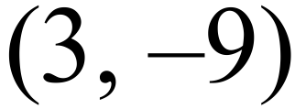
What is the y value, when the equations below are solved simultaneously?
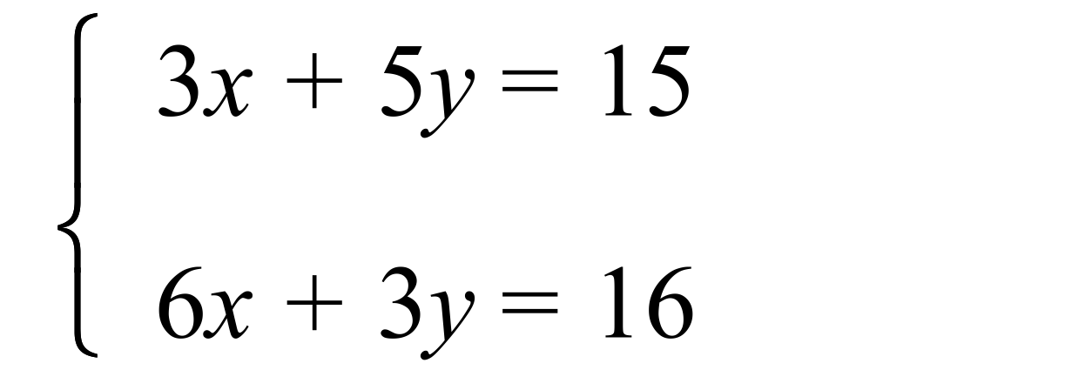
A. 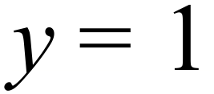

B. 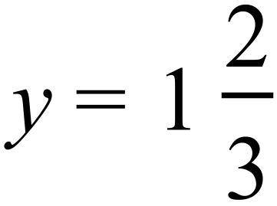

C. 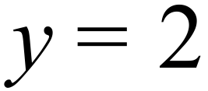

D. 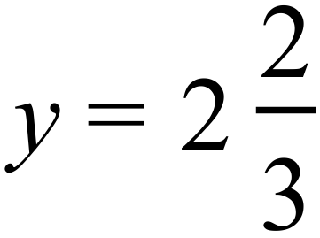

 | 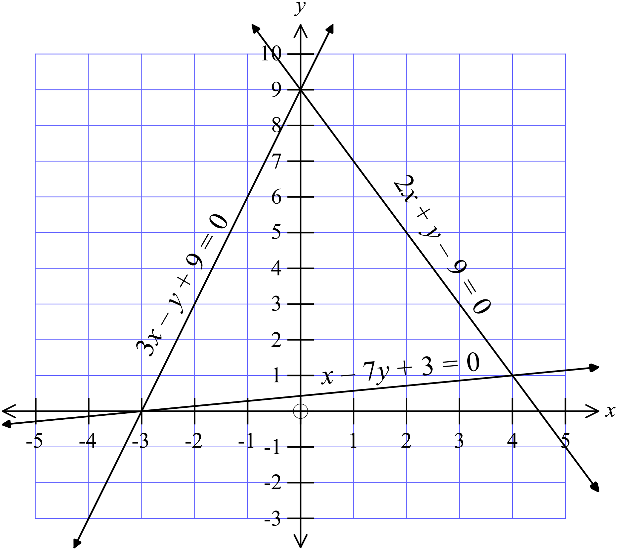Question 8 – 9 refer to the graph below.
Solve 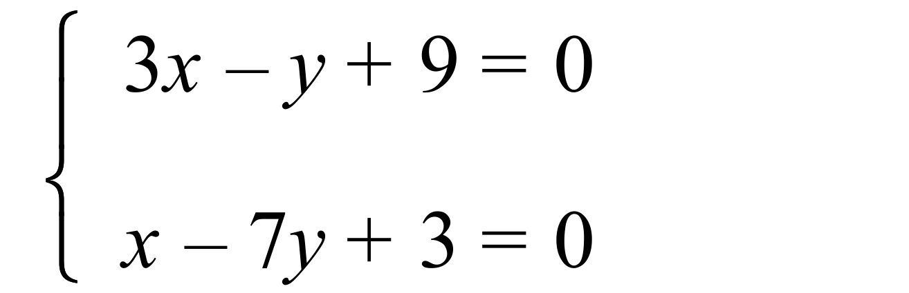

A. 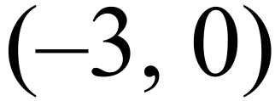 B. 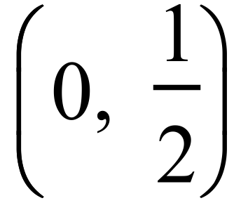 C. (0, 9) D. (4, 1)
Solve 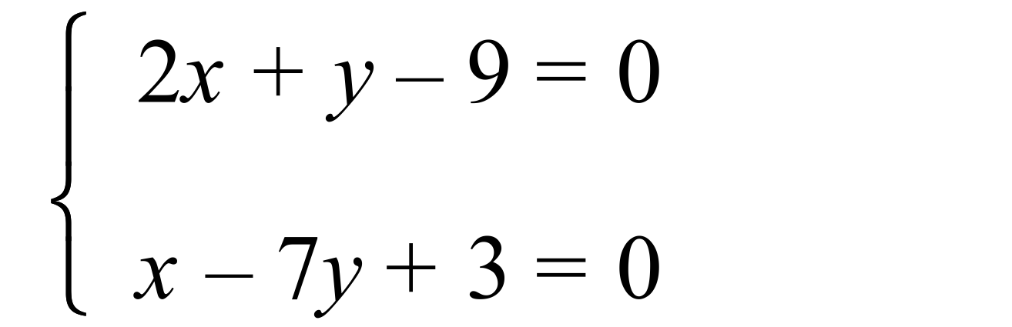

A. B. C. (0, 9) D. (4, 1)
Questions 10 – 12 refer to the following.
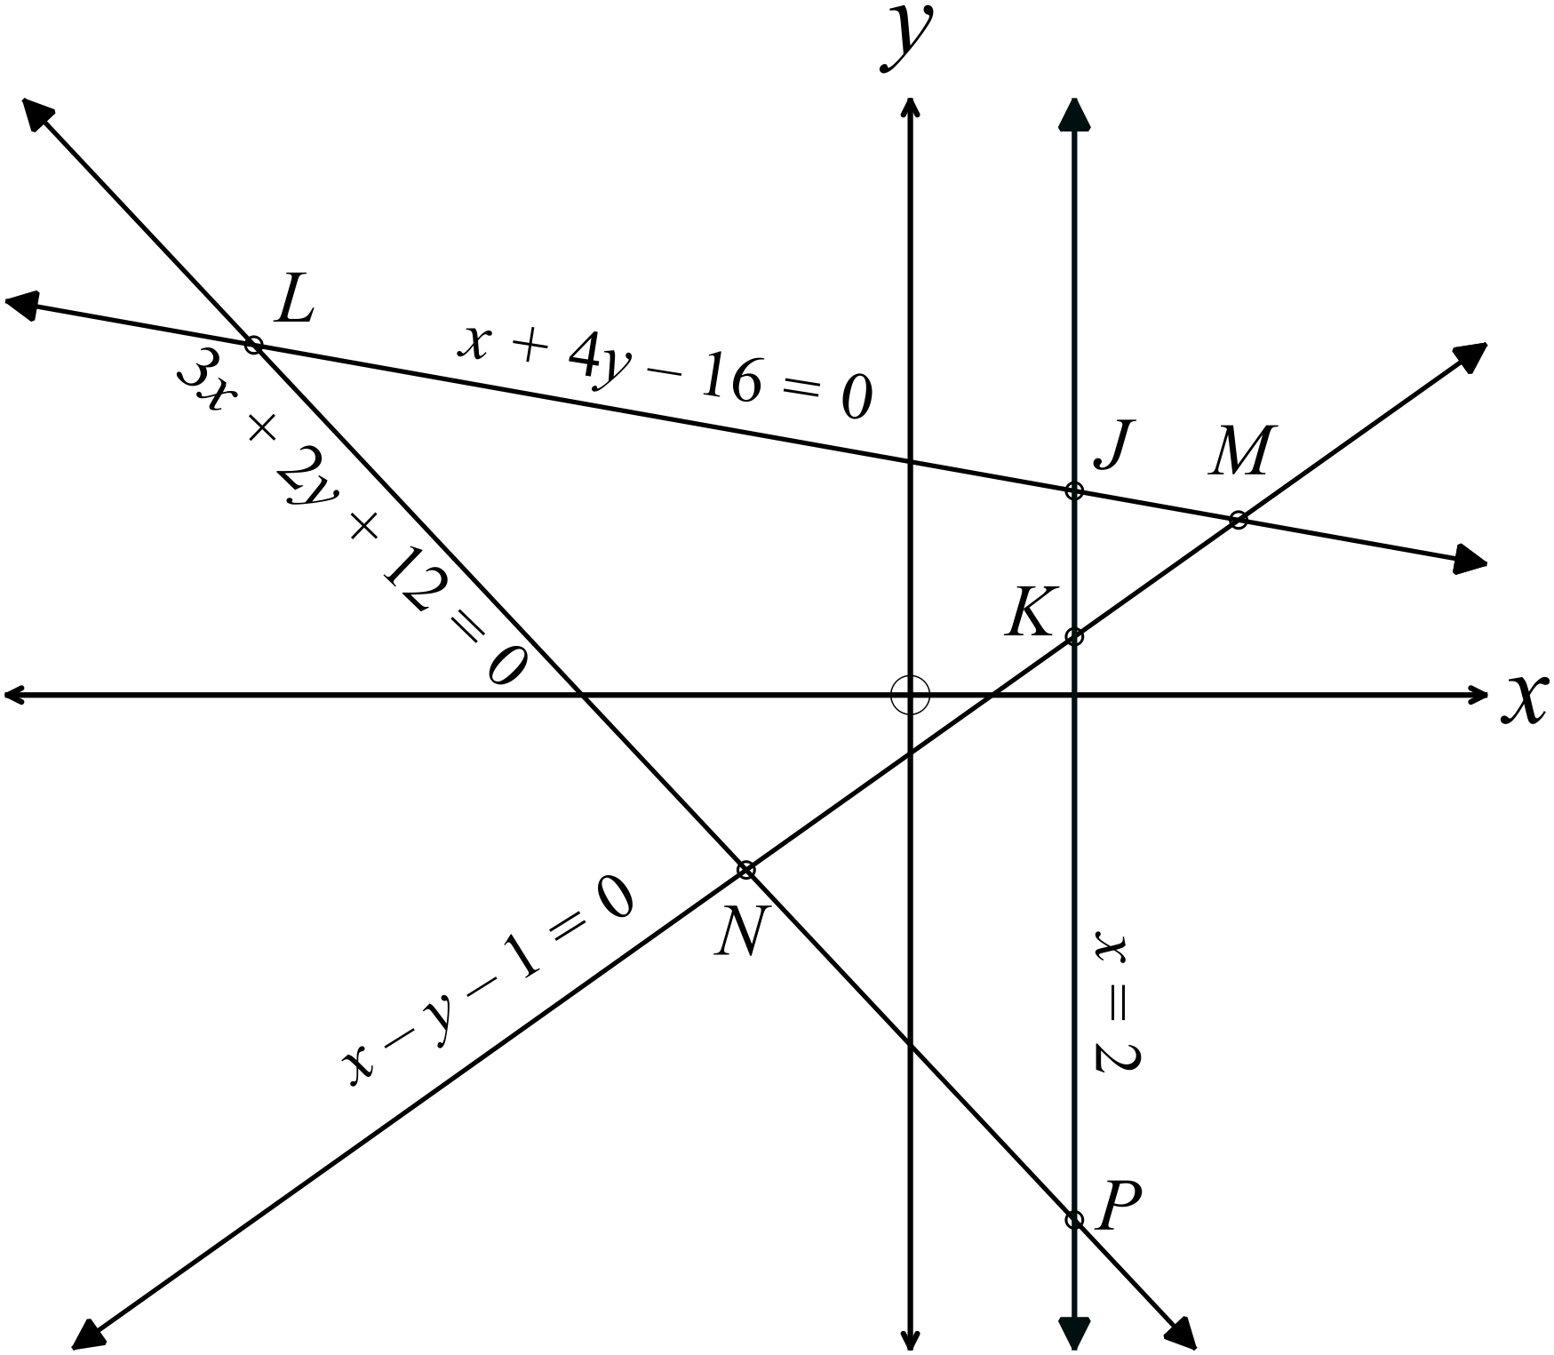The number plane shows the lines
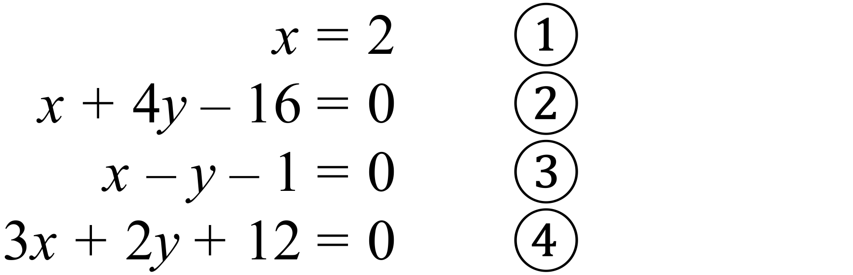

The points of intersection of these lines are labelled on the graph.

The point N is the solution to which pair of simultaneous equations?

A.

B.

C.

D.

Which point is the solution to the pair of equations:

A. Point L B. Point M C. Point N D. Point P
What are the coordinates of the point J ?

A. (2, -9) B. (2, 1) C. (2, 2.5) D. (2, 3.5)

Year 10 | Simultaneous Equations | Calculator Allowed
Year 10 | Simultaneous Equations | Name___________________
Section 3 Longer Answer Section
Write all working and answers in the spaces provided on this test paper.

 |  | Marks
1. | (a) Solve simultaneously: 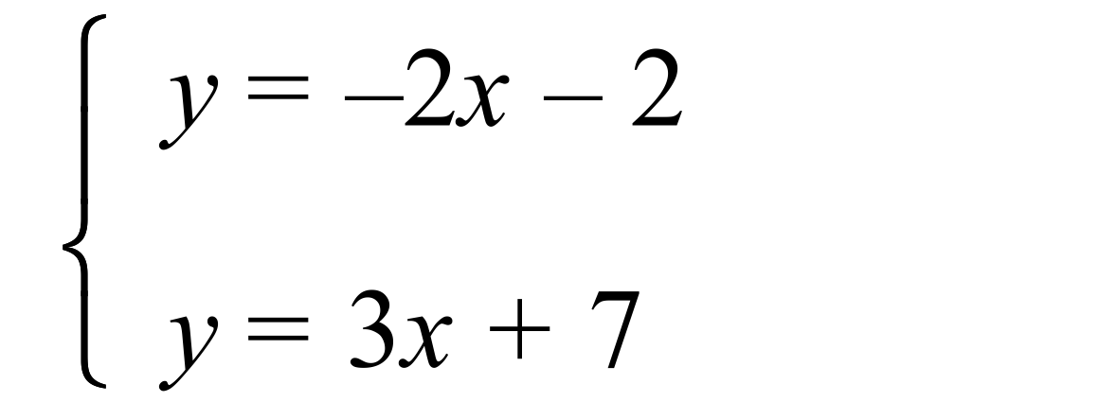  ……………………………………………………………………………………………....  ……………………………………………………………………………………………....  ……………………………………………………………………………………………….  ……………………………………………………………………………………………....  ………………………………………………………………………………………………. | 3
 | (b) Solve simultaneously: 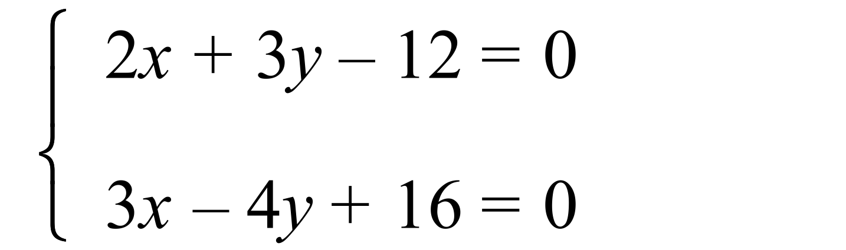  ……………………………………………………………………………………………....  ……………………………………………………………………………………………....  ……………………………………………………………………………………………....  ……………………………………………………………………………………………….  ……………………………………………………………………………………………....  ………………………………………………………………………………………………. | 3
2. | The line 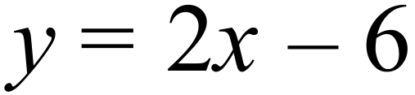 is shown on the graph below.  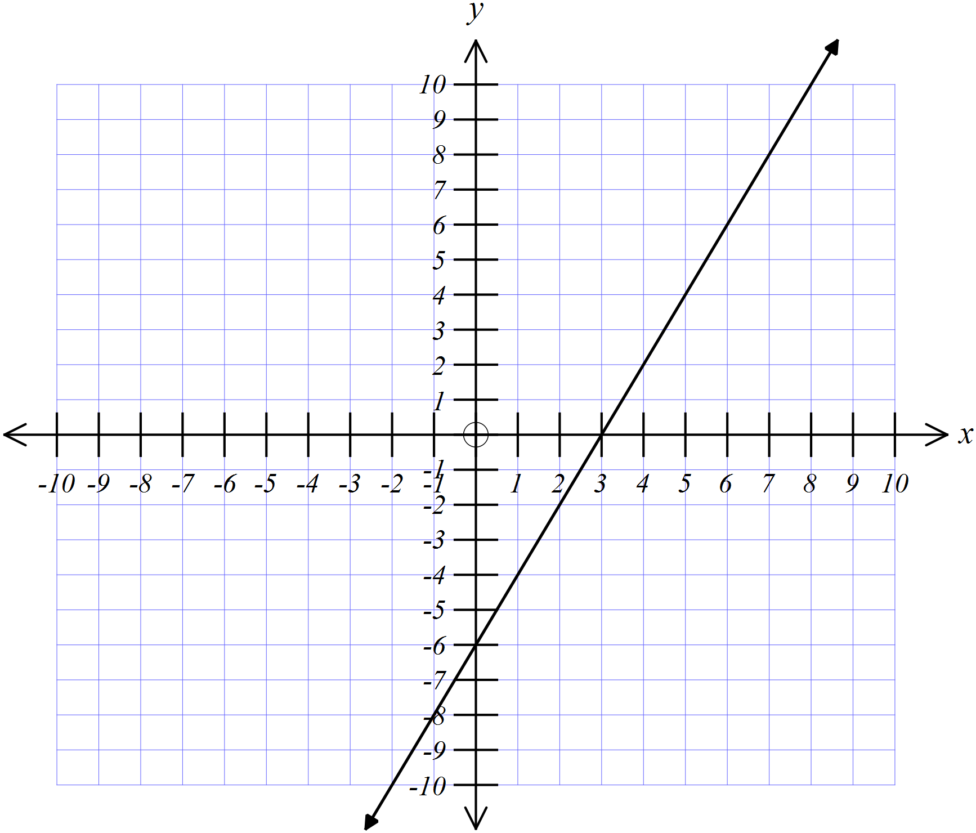
 | (a) Draw the lines | 2
 | (b) Solve simultaneously with 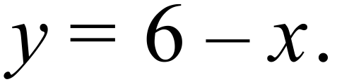  ………………………………………………………………………………………………. | 1
 | (c) Solve simultaneously with 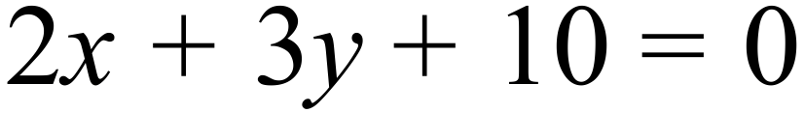  ………………………………………………………………………………………………. | 1

Multiple Choice Answer Sheet
Simultaneous Equations
Name _____________________________________________
Completely fill the response oval representing the most correct answer.

1. A B C D
2. A B C D
3. A B C D
4. A B C D
5. A B C D
6. A B C D
7. A B C D
8. A B C D
9. A B C D
10. A B C D
11. A B C D
12. A B C D
Year 10 |  | Simultaneous Equations | Non Calculator
Section 1 Short Answer Section
ANSWERS
No. | WORKING |  | ANSWER
 | 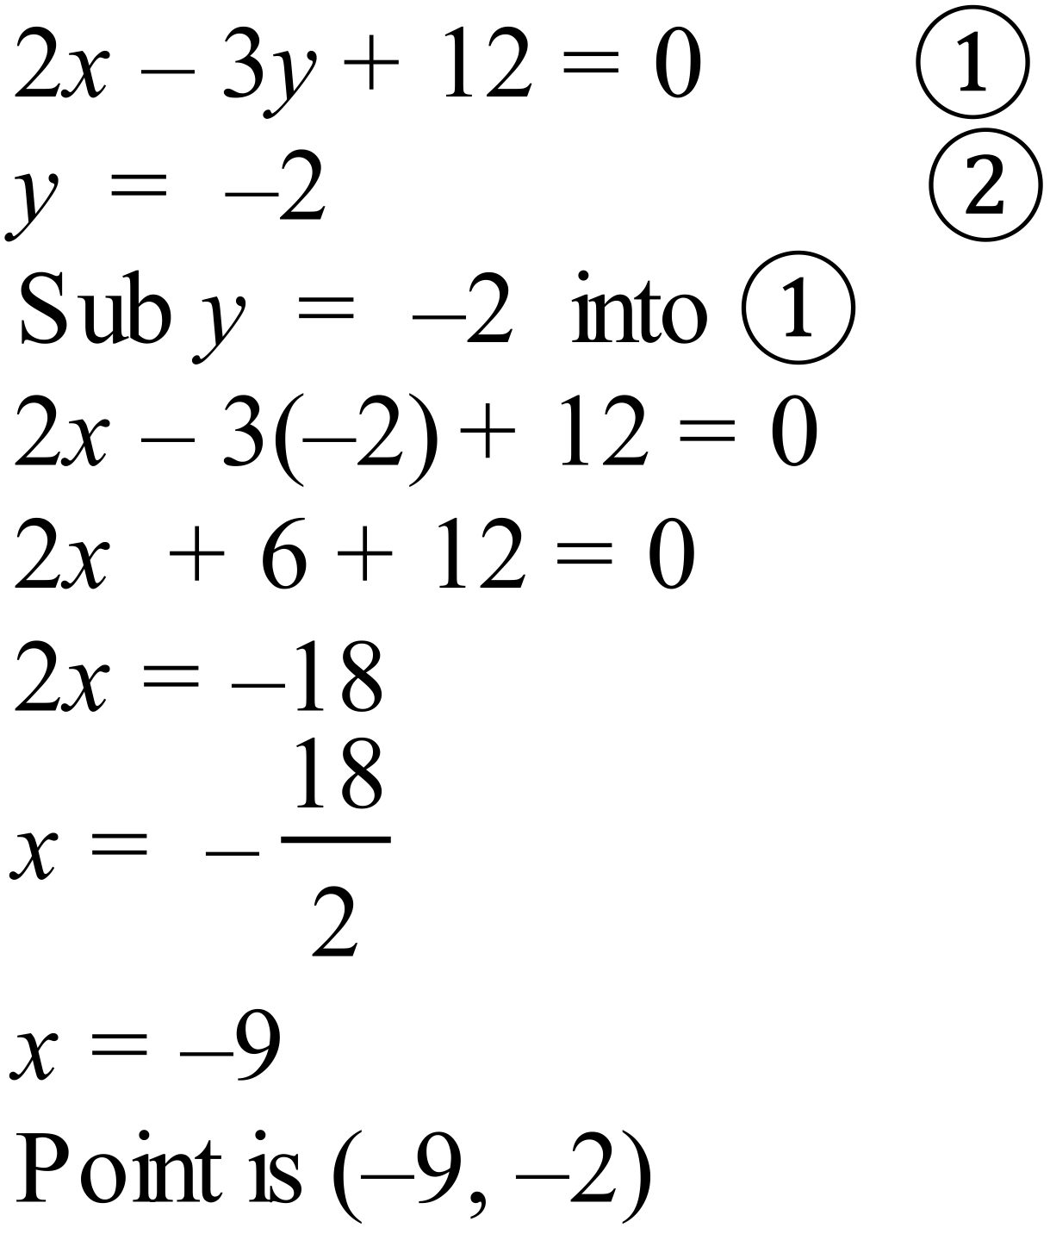 |  | 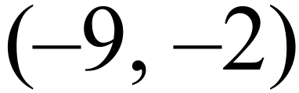
 | 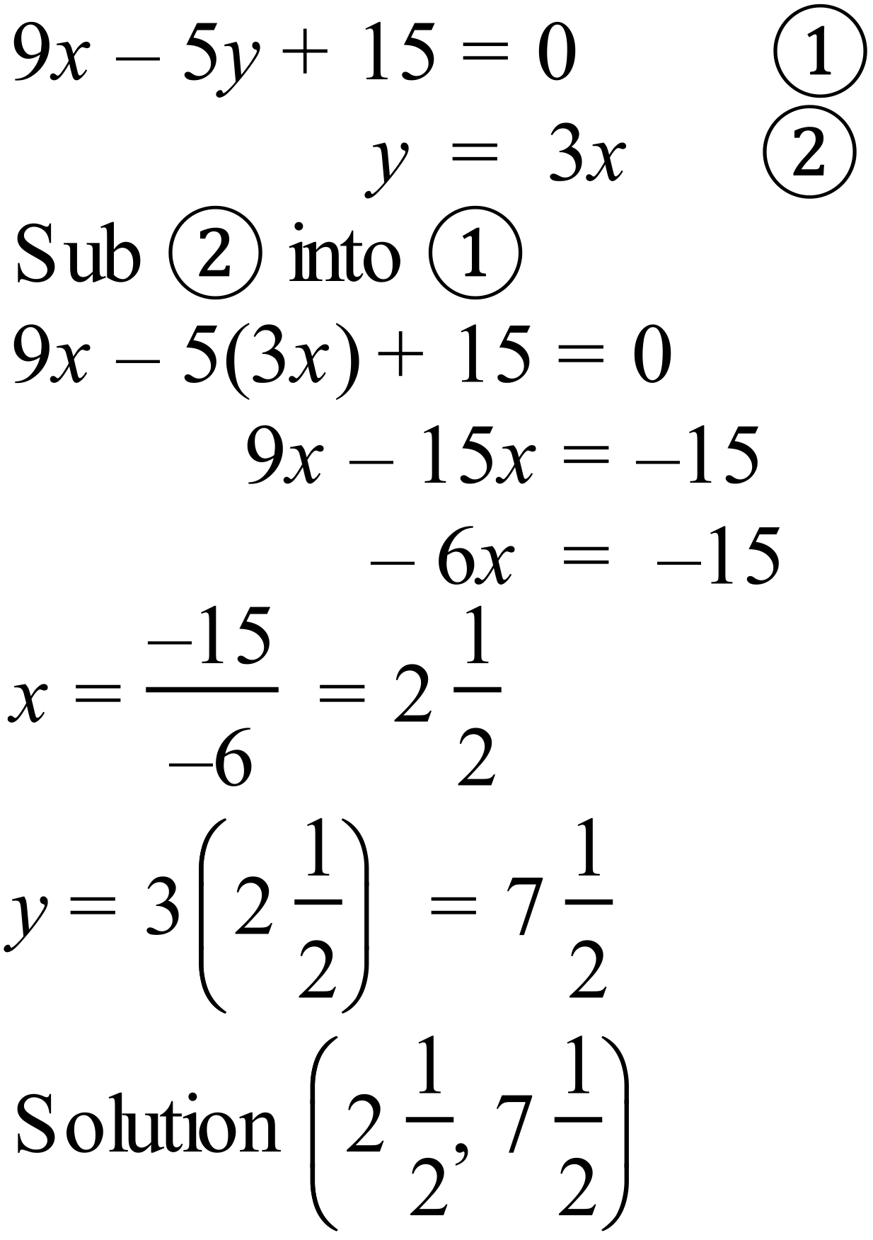 |  | 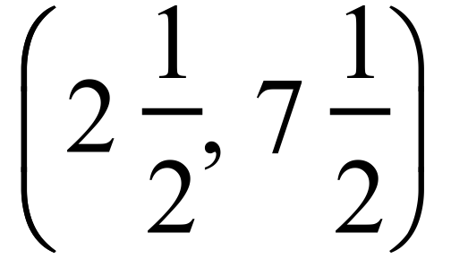
 | 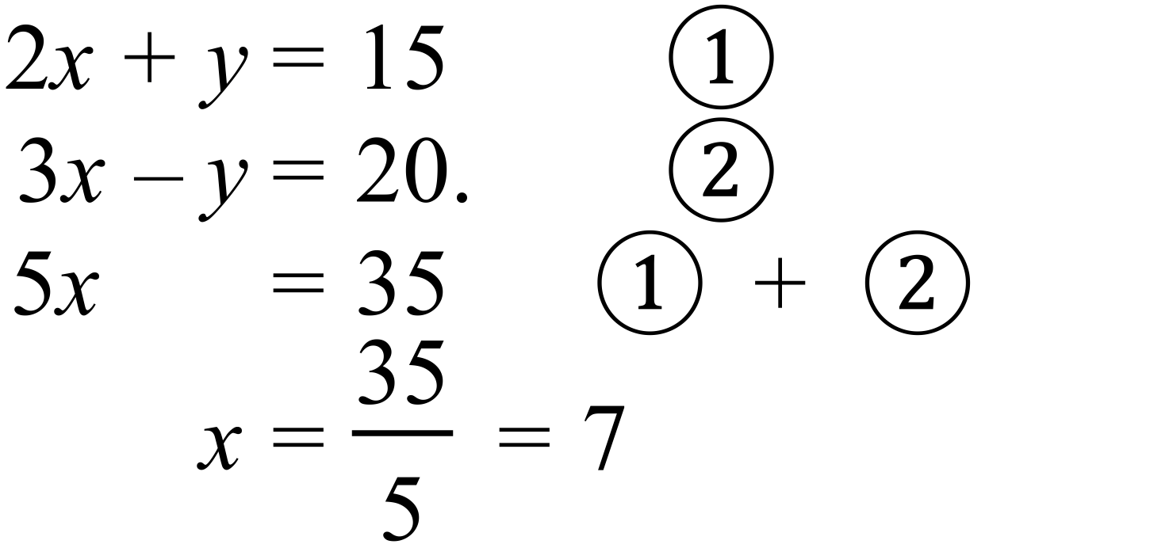 |  | 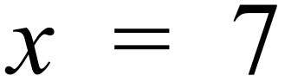
 | 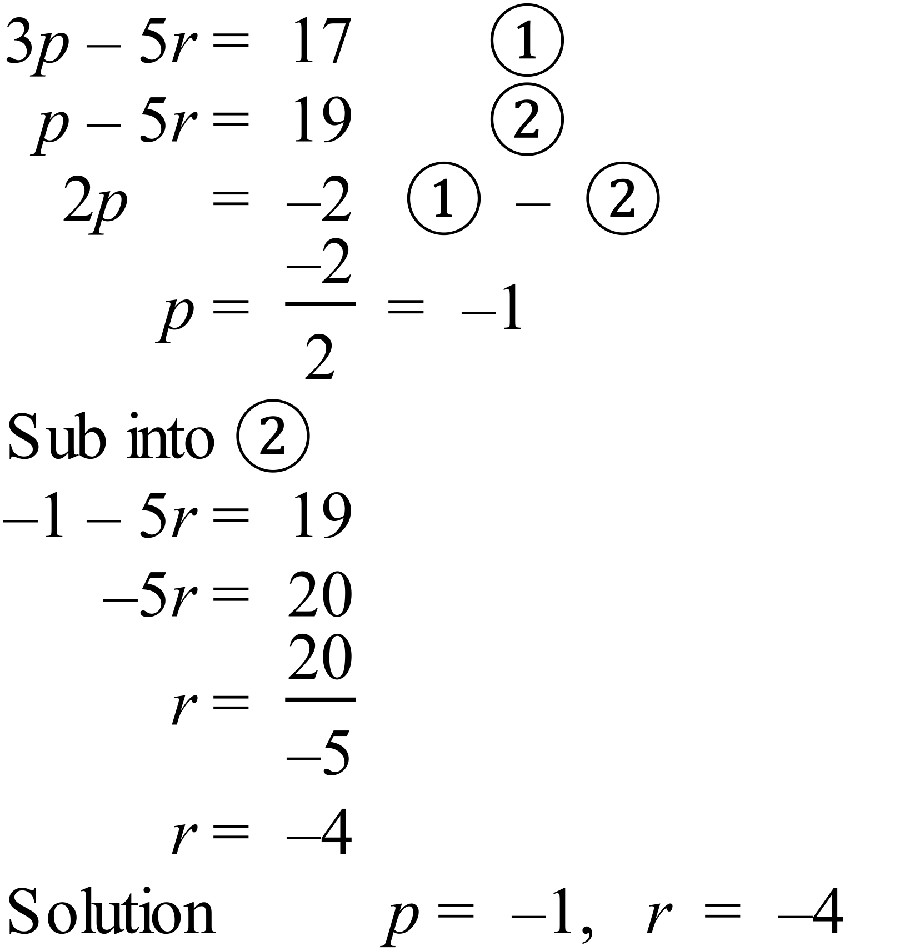 |  | 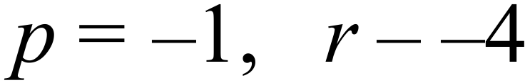
 | 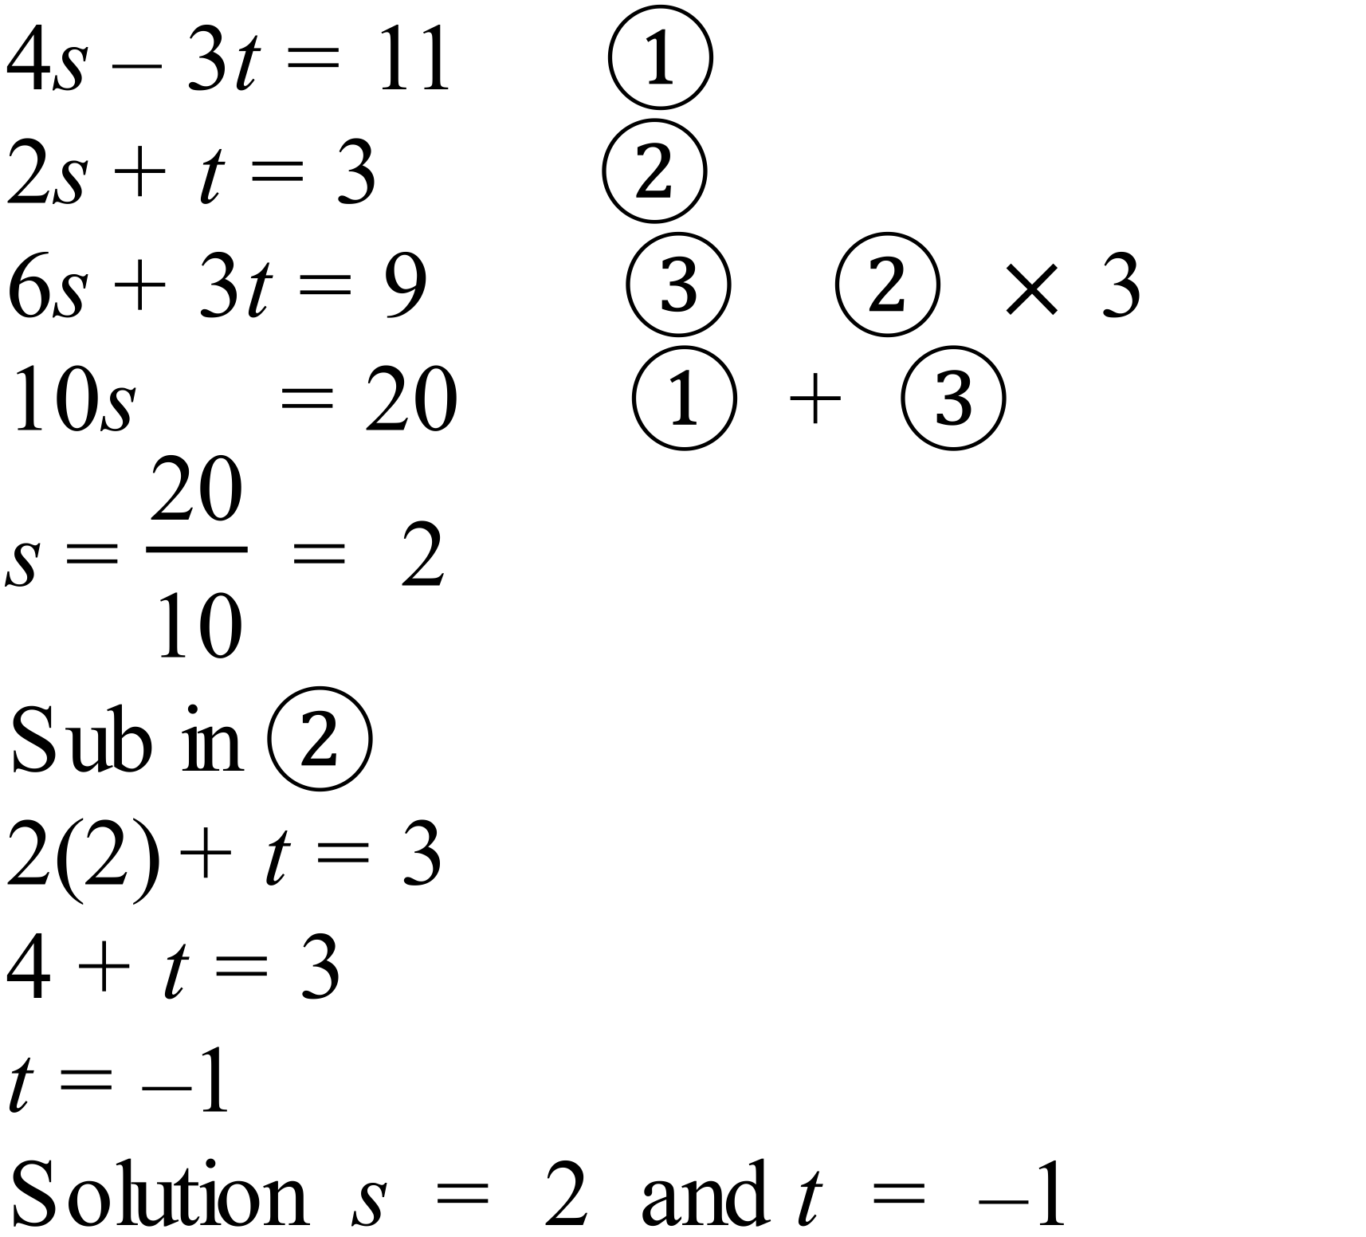 |  | 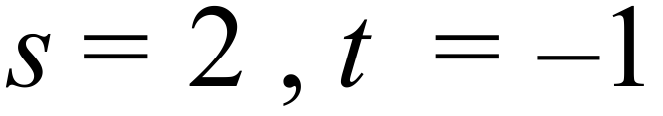
 | 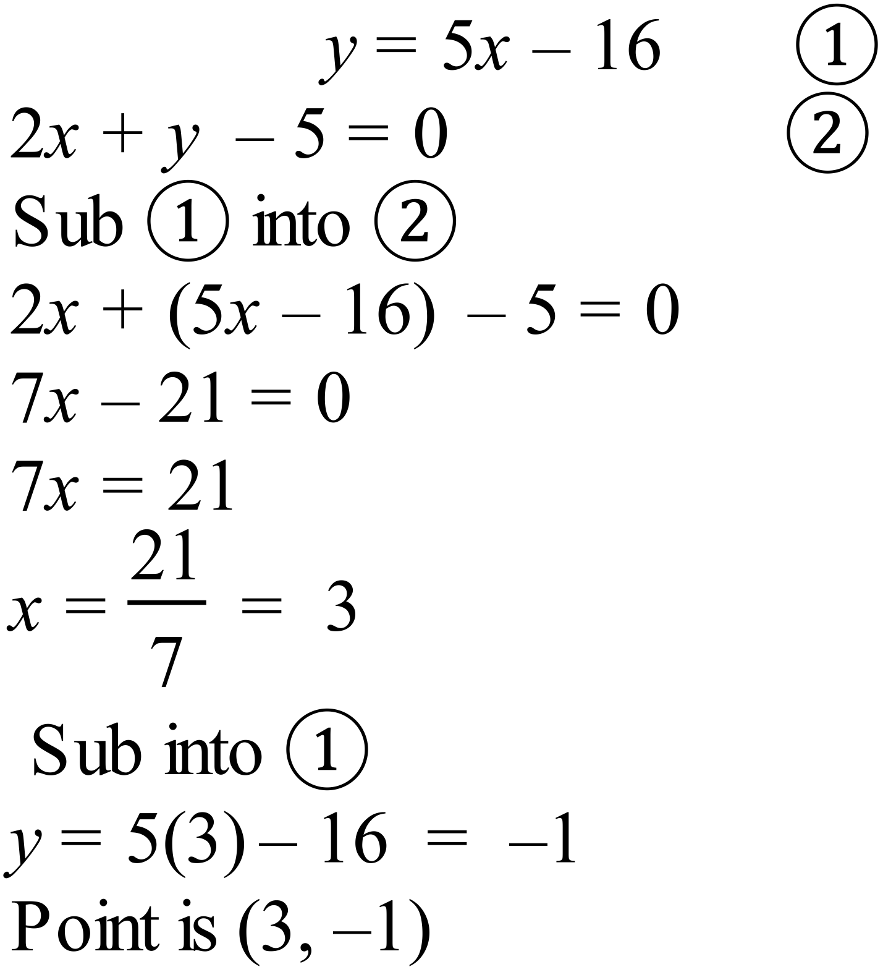 |  | 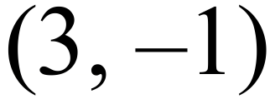
 | 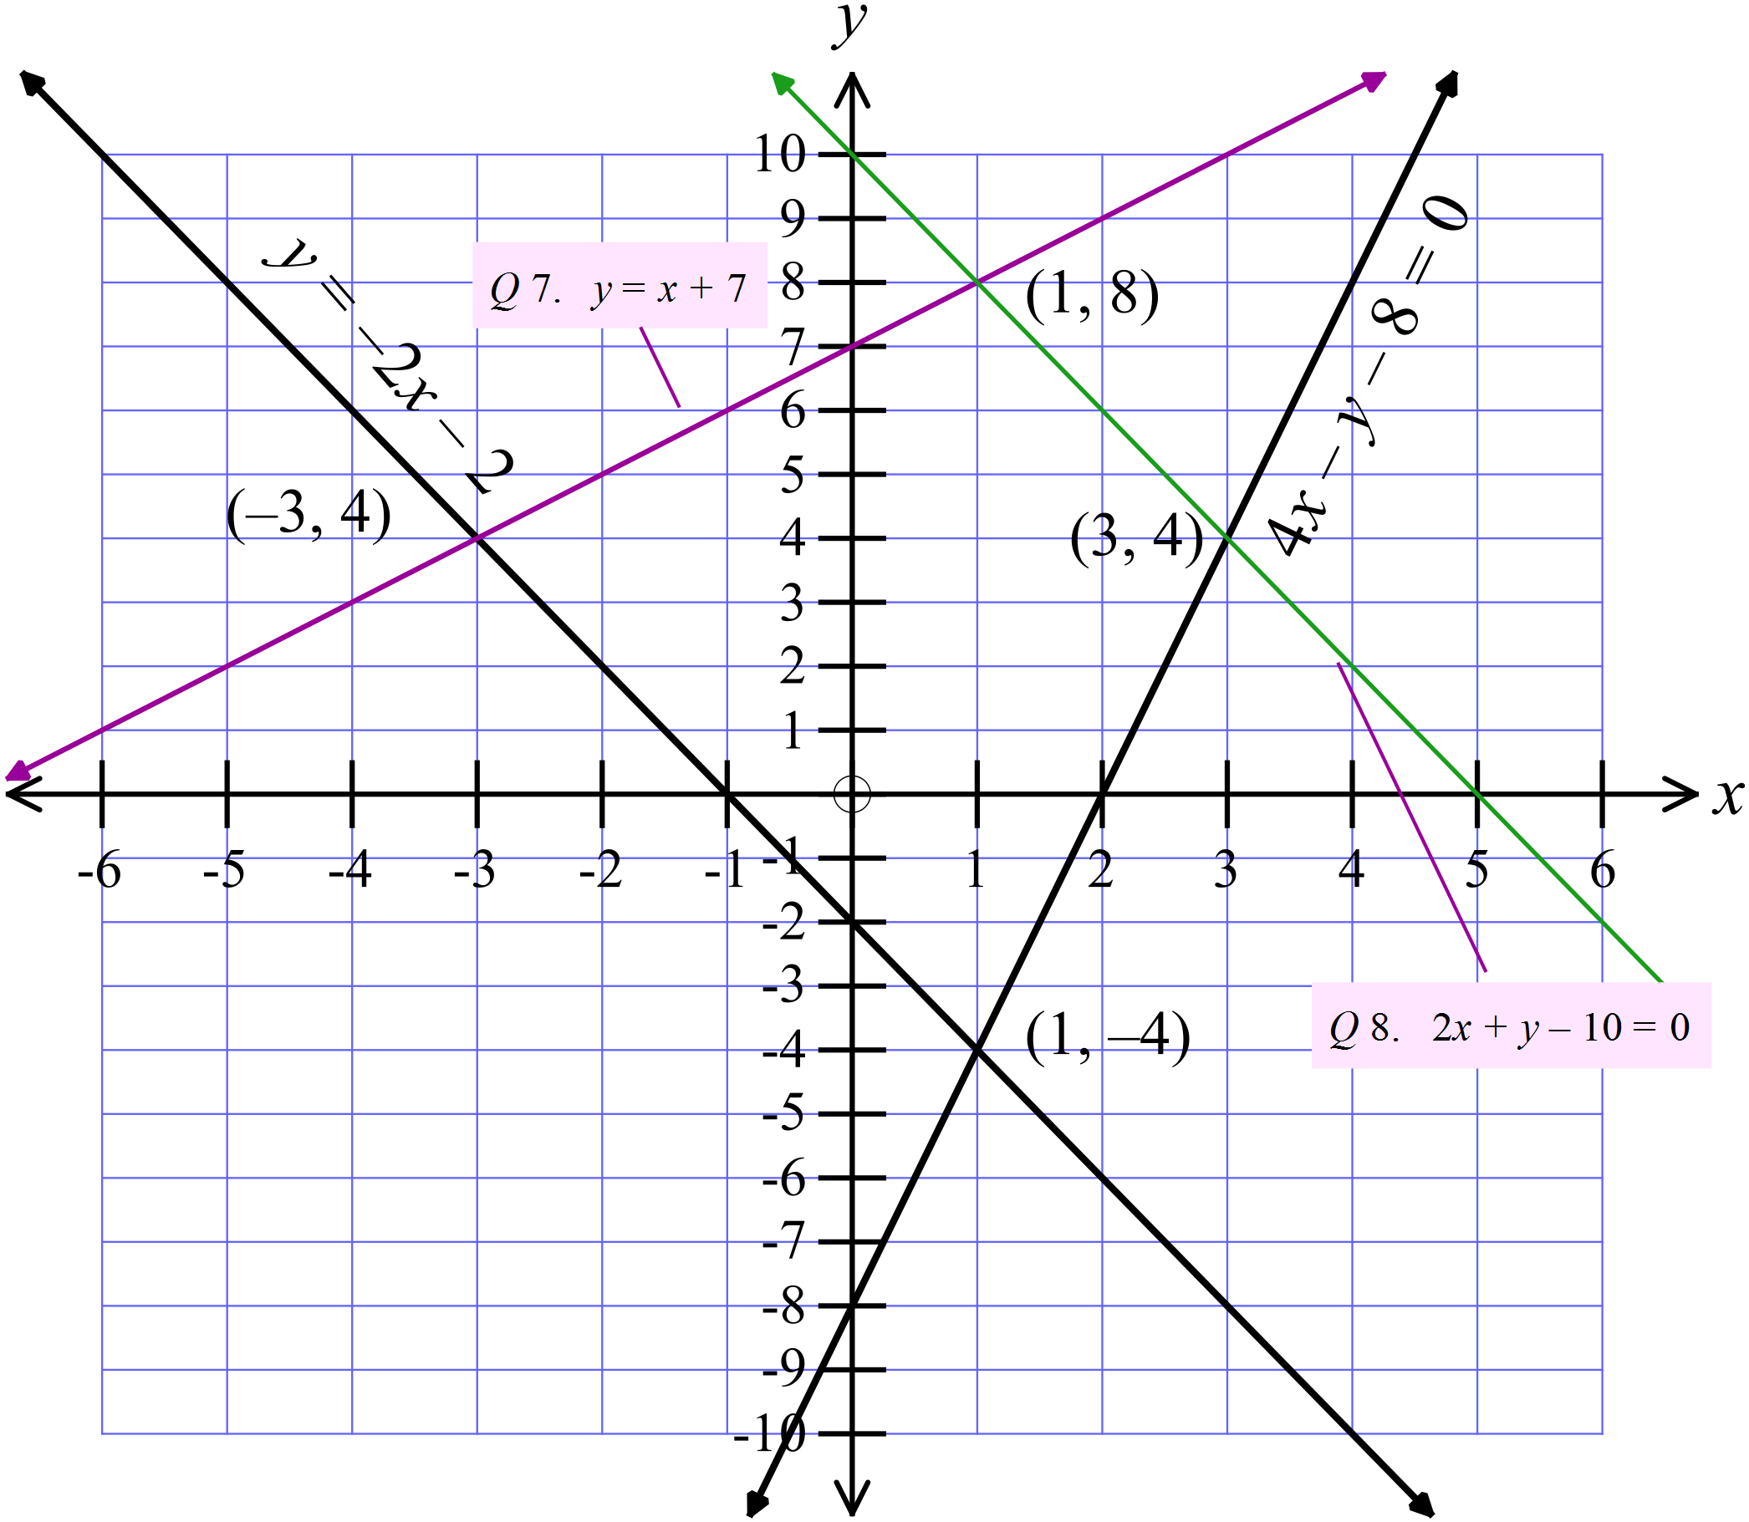
 | See graph above |  | Line on graph
 | See graph above |  | Line on graph
 | 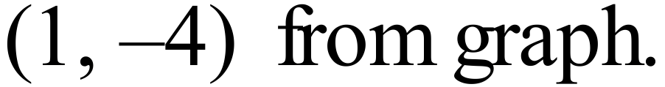 |  | 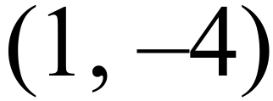
 | 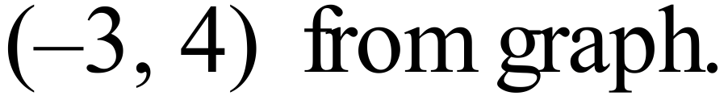 |  | 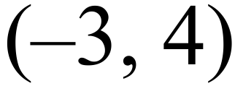
 | 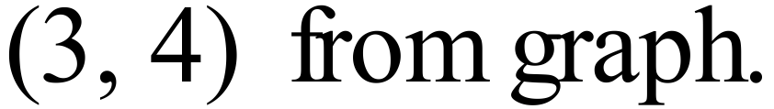 |  | 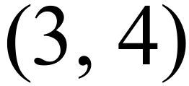
 | 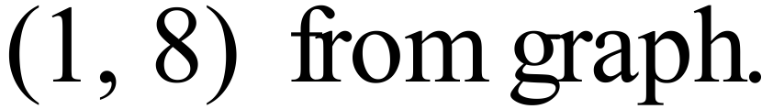 |  | 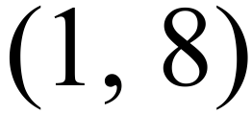

Year 10 |  | Simultaneous Equations | Calculator Allowed
Section 2 Multiple Choice Section
ANSWERS
No. | WORKING |  |  | ANSWER
 | 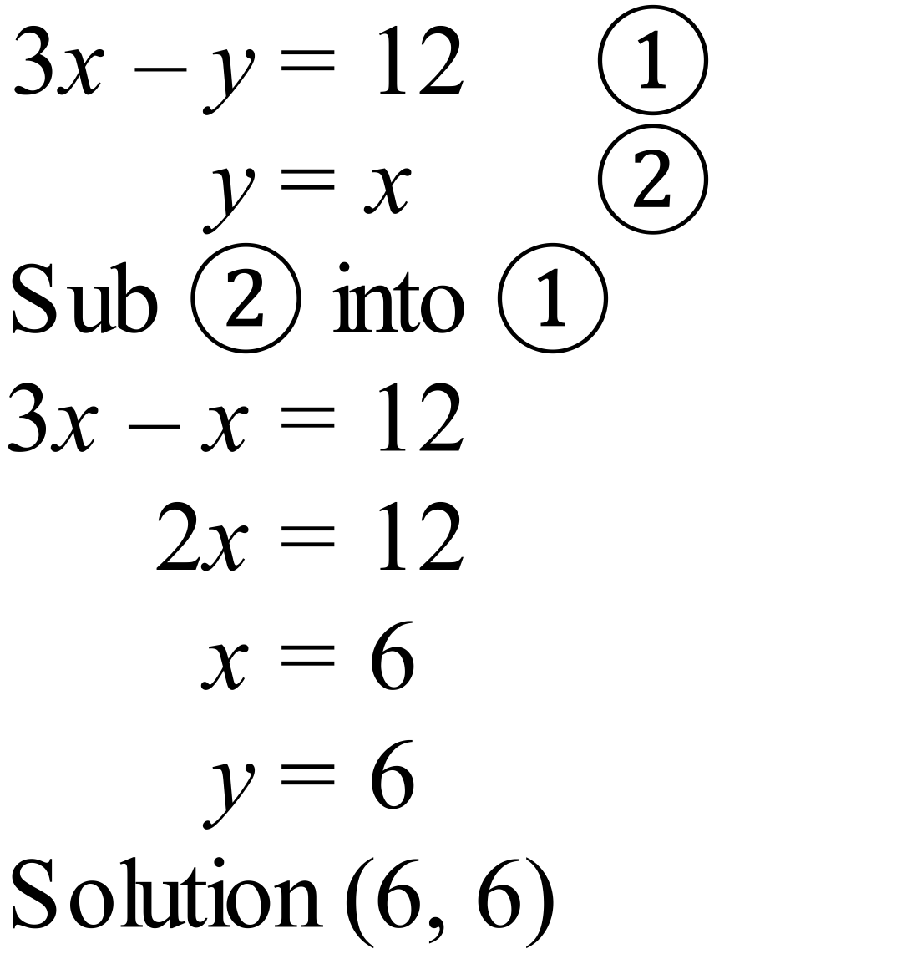 |  |  | C
 | 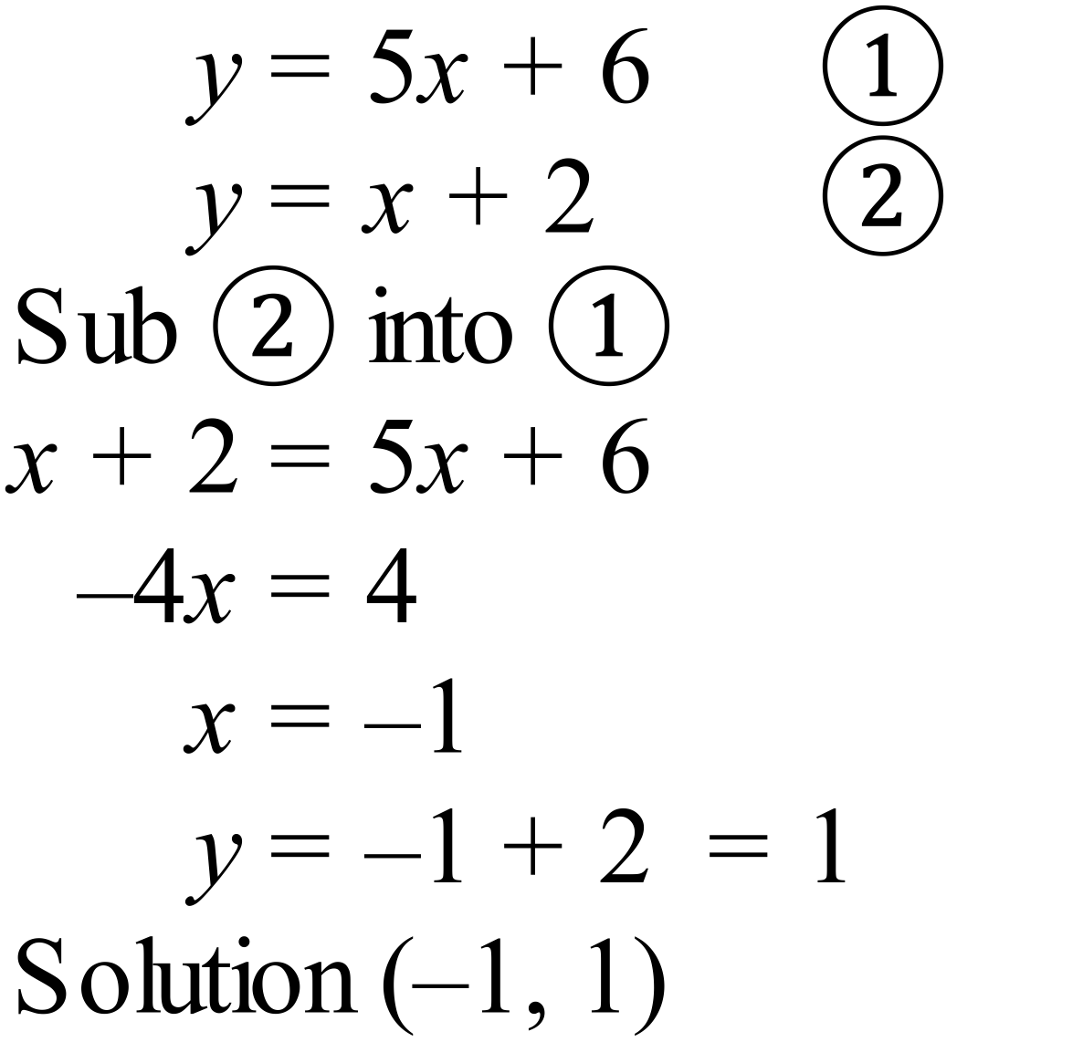 |  |  | B
 | 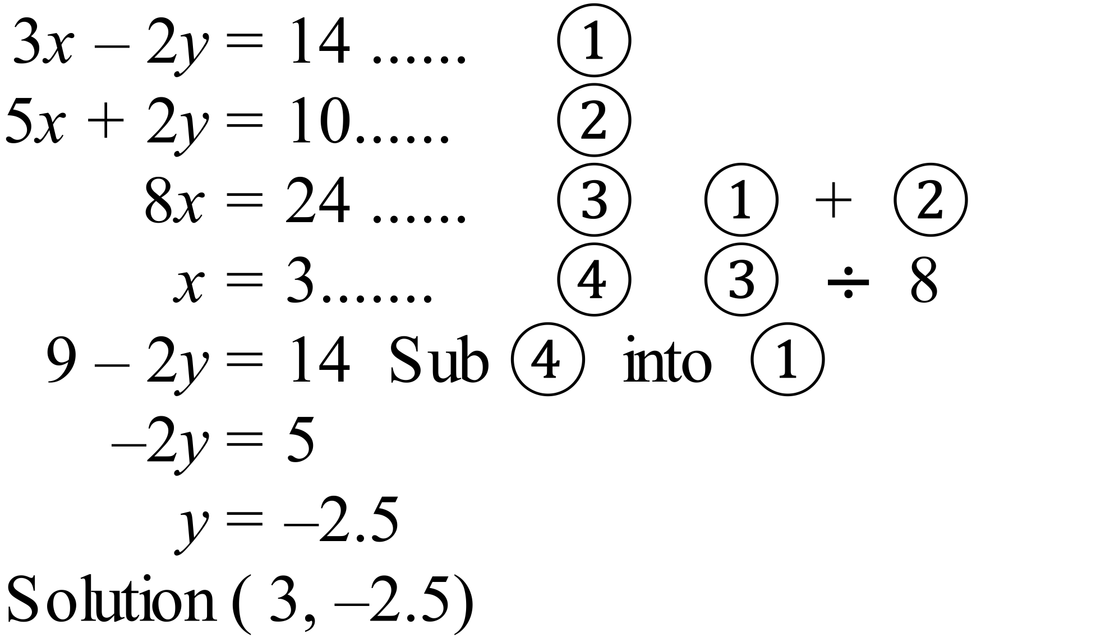 |  |  | D
 | See above |  |  | A
 | 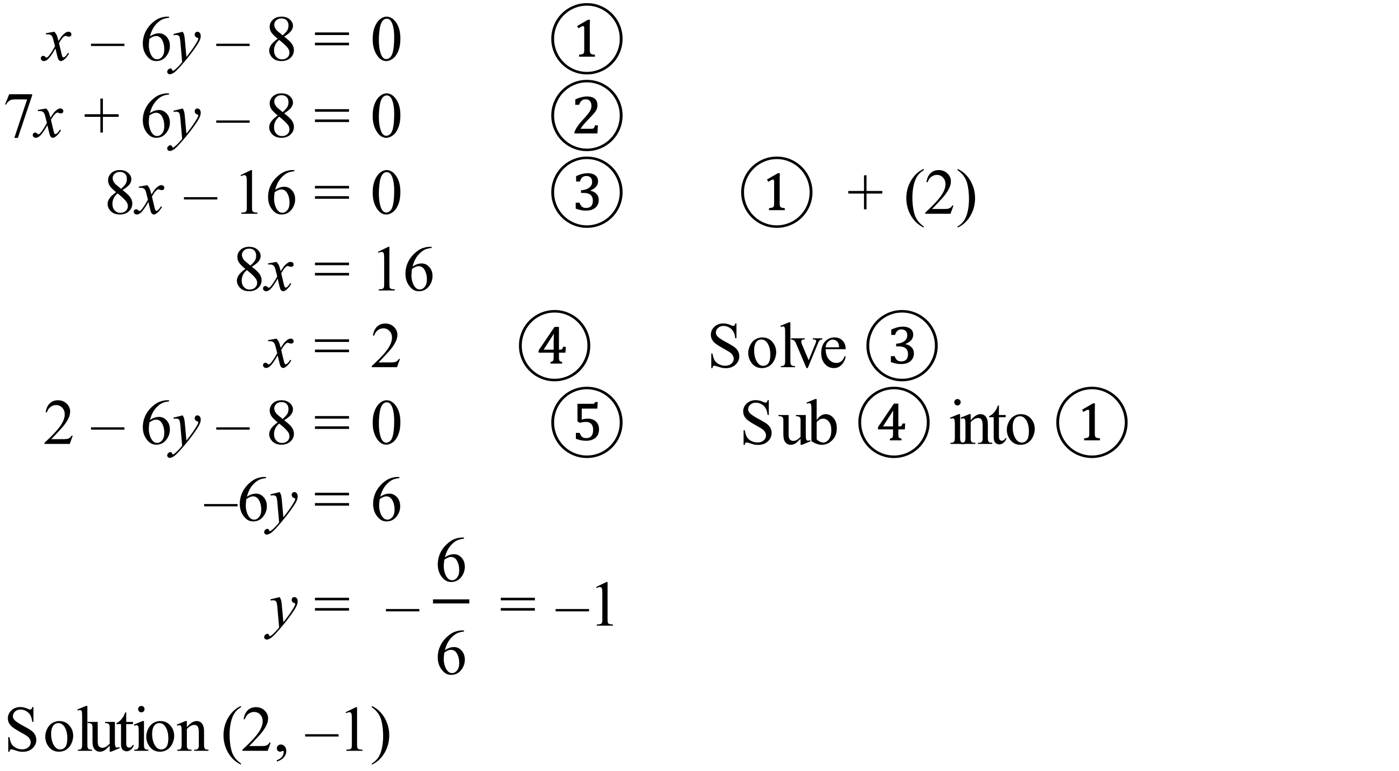 |  |  | D
 | 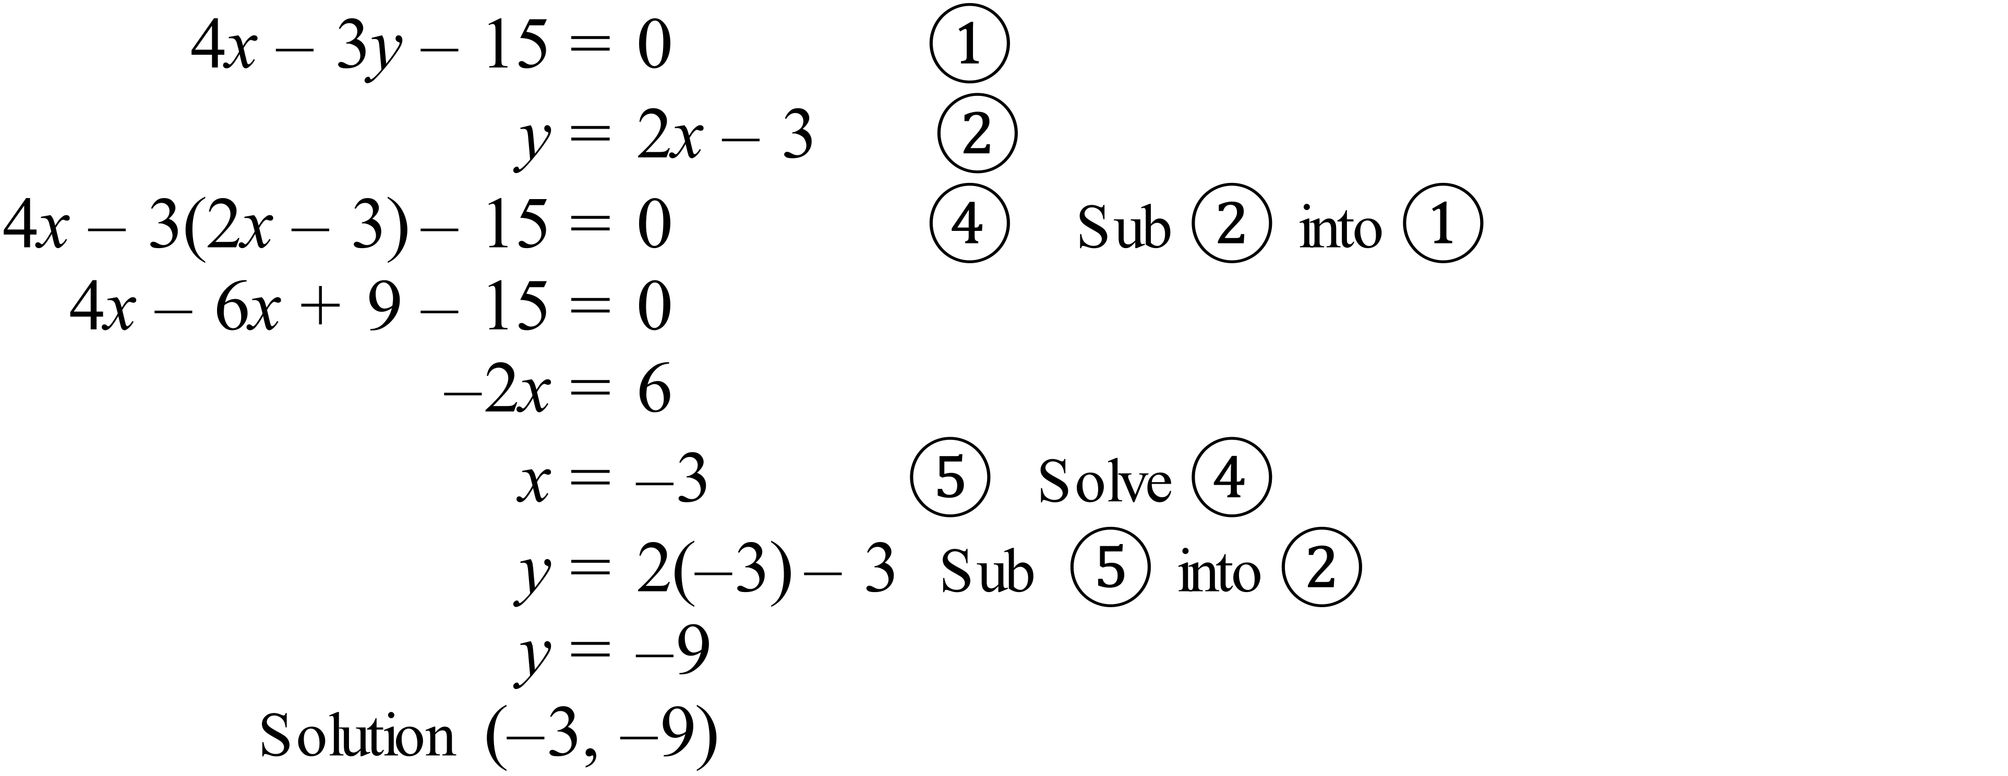 |  |  | B
 | 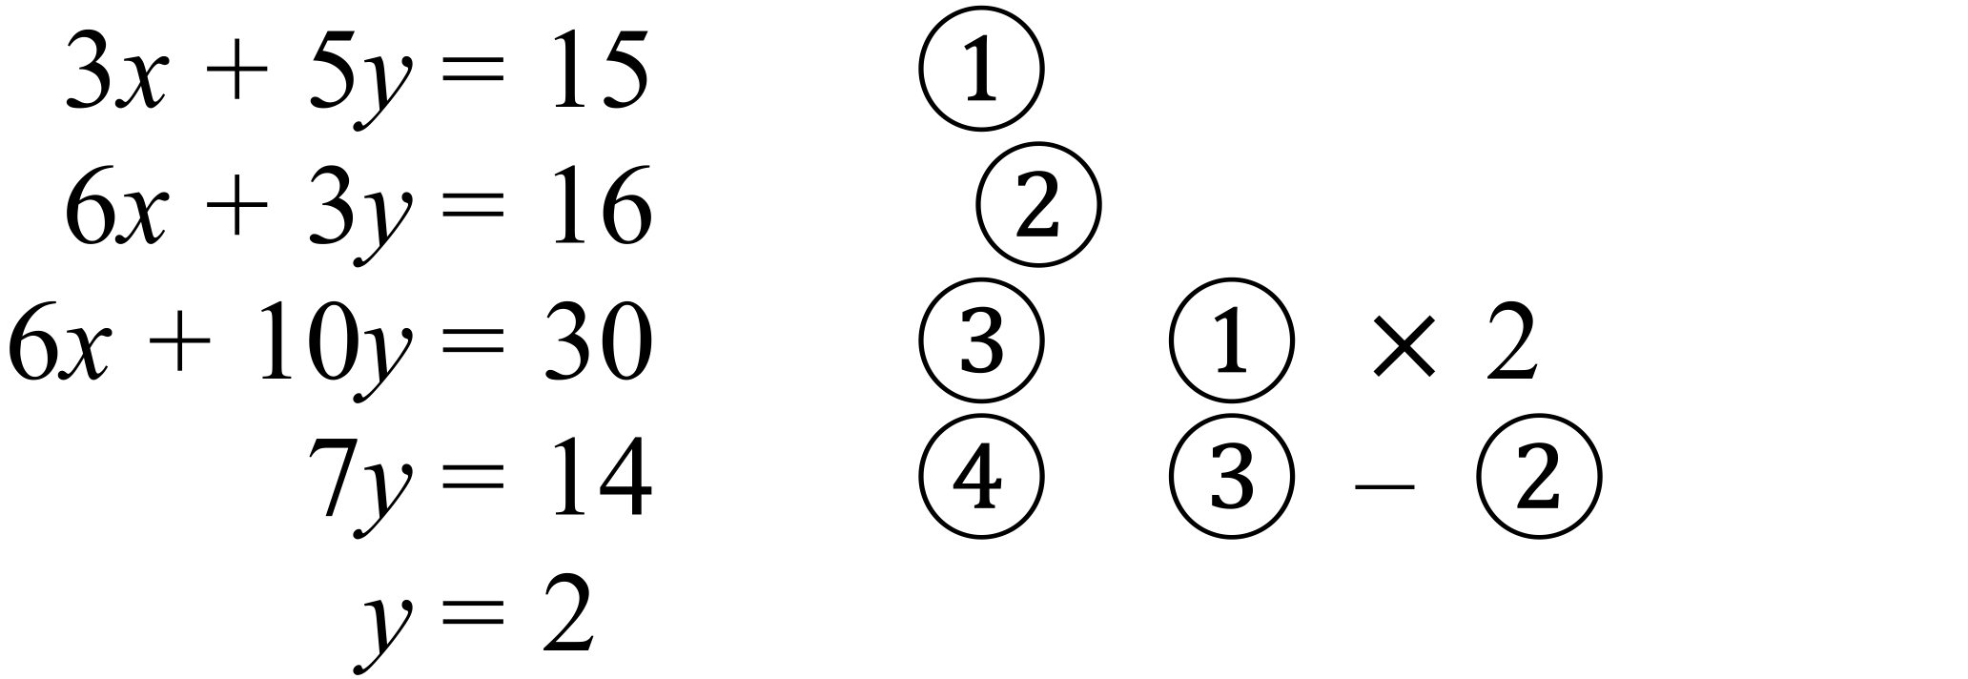 |  |  | C
 |  |  |  | A
 | (4, 1) |  |  | D
 | from Graph. |  |  | C
 | Point M from Graph. |  |  | B
 | 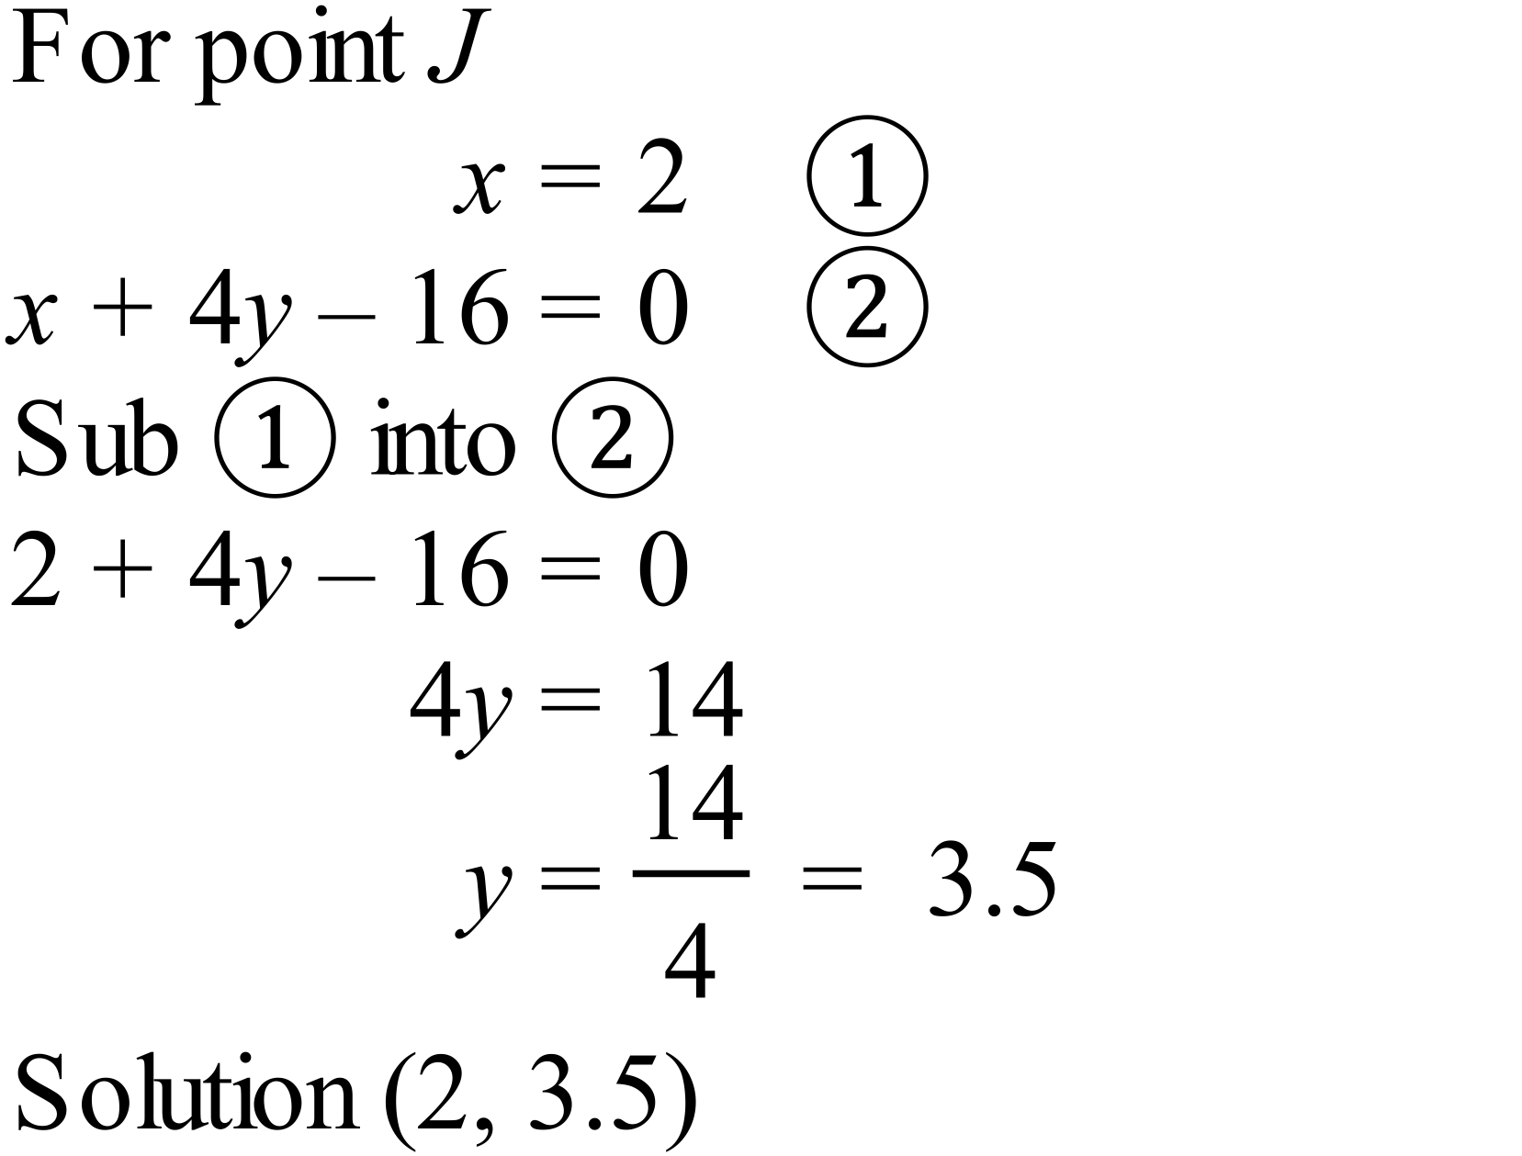 |  |  | D

Multiple Choice Answer Sheet
Simultaneous Equations
Name _______ANSWERS_______________________________
Completely fill the response oval representing the most correct answer.

1. A B C D
2. A B C D
3. A B C D
4. A B C D
5. A B C D
6. A B C D
7. A B C D
8. A B C D
9. A B C D
10. A B C D
11. A B C D
12. A B C D
Year 10 |  | Simultaneous Equations | Calculator Allowed
Section 3 Longer Answer Section
ANSWERS
 |  |  |  |  | Marks
1. | (a) 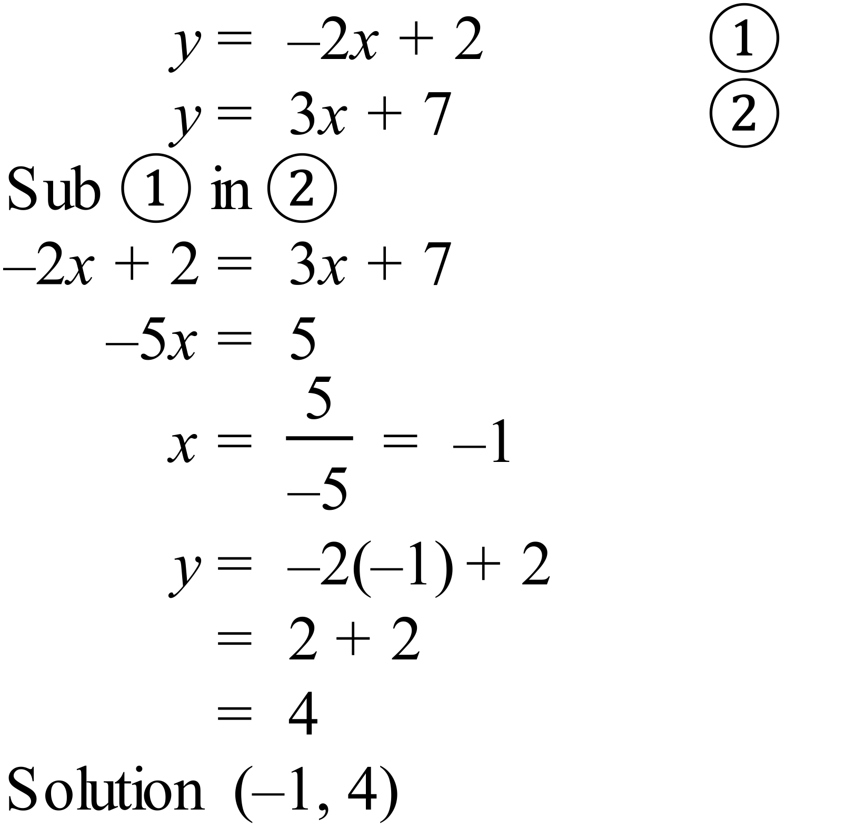 |  |  | 3 marks for correct answer with working.  2 marks for almost complete partial answer, or incorrect answer with only minor errors  1 mark for some basic working on the right course
 | (b) 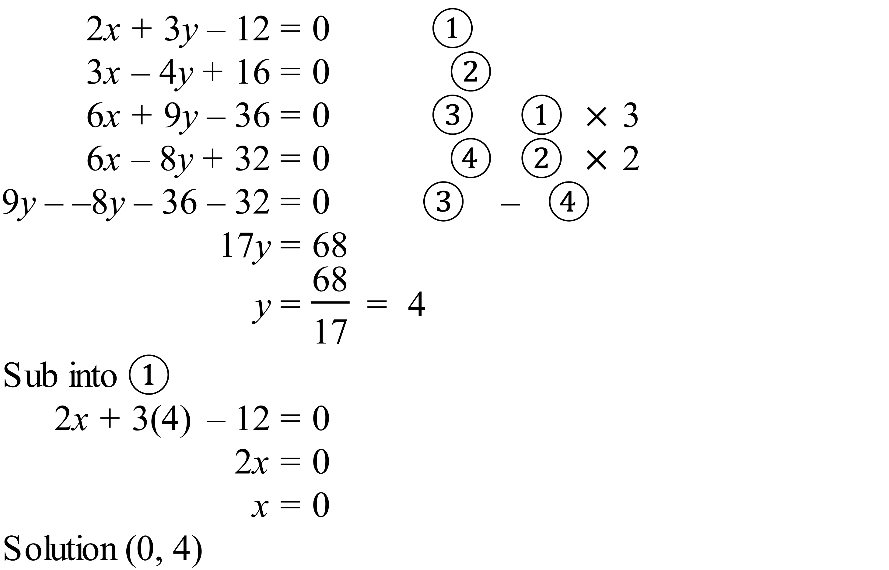 |  |  | 3 marks for correct answer with working.  2 marks for almost complete partial answer, or incorrect answer with only minor errors  1 mark for some basic working on the right course
2. | (a)  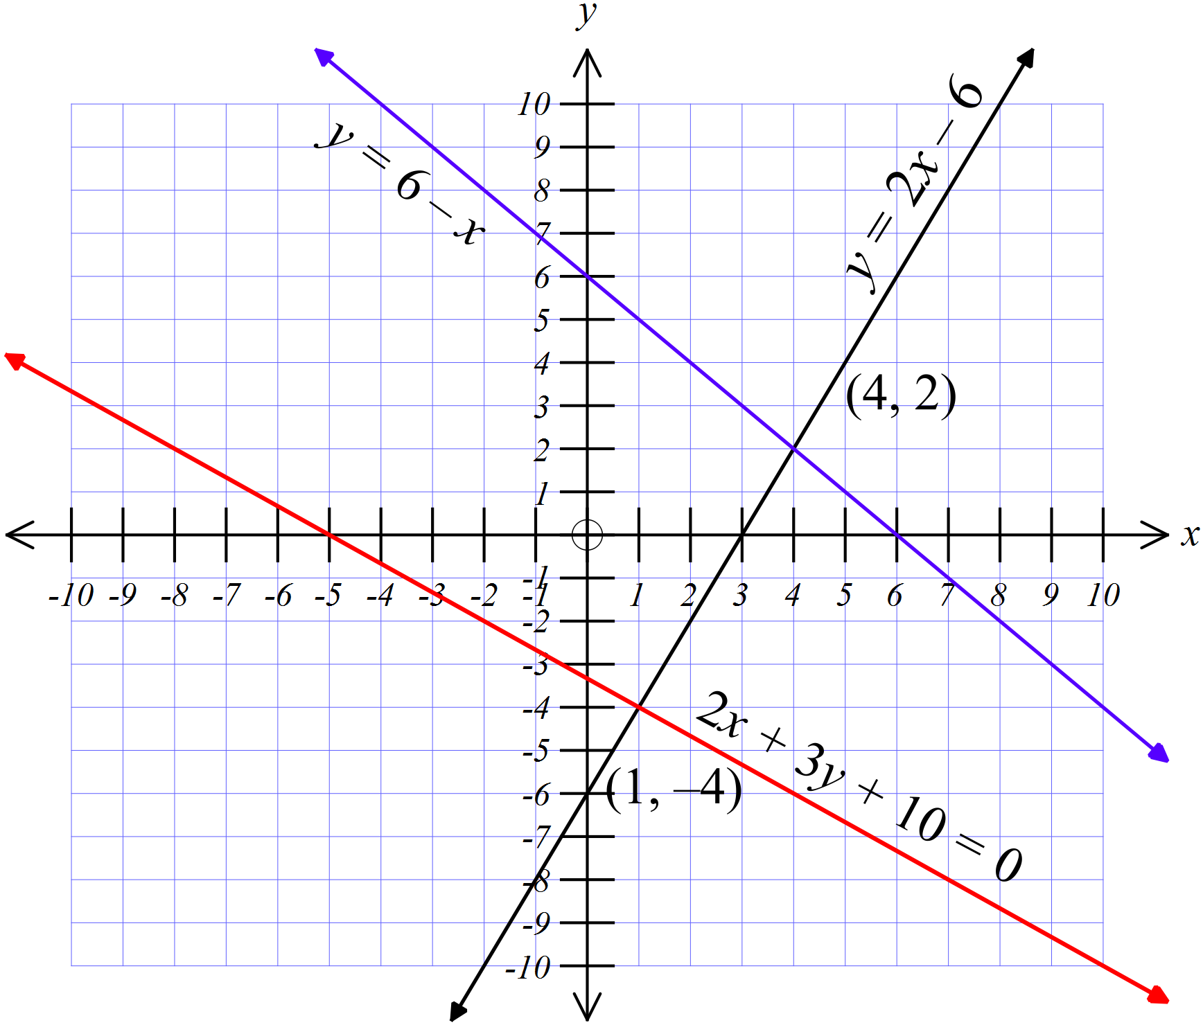 |  |  | 1 mark for each of the red and blue lines on this graph
 | (b) (4, 2) |  |  | 1 mark for correct point read from graph
 | (c) (1, -4) |  |  | 1 mark for correct point read from graph

